Logic:

See we can only do this at most once meaning 1 time or 0 time.

See in this we will go from c checking the next smaller character and that will be a and hence change it.

But here that will not work as d after smaller is c but ans would be acbd as smallest.

See here a next nothing is more smaller than it and hence let it remain as it is.we cant take next element at index 1 and replace it by a will come below

Hence can’t do it like that. But we can let a remain as it is and then for next d smaller is c and hence, we can replace all d with c. But there remains b too and hence d next smallest is b and hence replace d with b.

See we will take a set and by putting element in it this will gives us the element in sorted order.

Now run a loop. delete c from the set as we need to check it next smallest. See if c not replace then at any index of c comes, we don’t need to check as we already know that c was not replaced earlier. Now we see that smaller element is a and hence we can replace them as smallest in set. See since c already removed from set and hence we will not find this when checking set.

Then break the loop. Now next example.

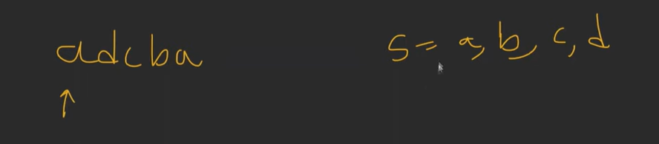

See here a is at index 0.remove this from the set.

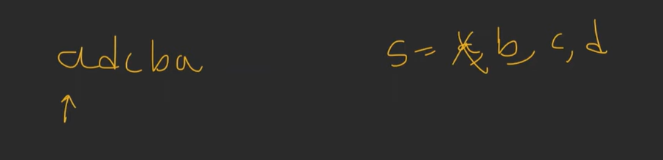

Now see the smallest which is not coming. Go to next index and see for d and remove this from the set. Here we will find b and hence replace all d with b and vice versa.

Code:

